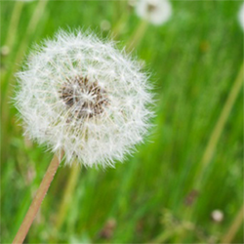

**Environmental Impact Statement**

Organic lawn care will result in a healthy lawn free of harmful and dangerous chemicals. There are many benefits of organic lawn care. The benefits are: A) it is safe for your family and pets, b) it is cheaper than “traditional chemical” programs, c) improves plant and lawn quality, d) low environmental impact, e) provides microbial activity, f) builds organic matter in soil, increasing soil health, and g) it reduces the impact of a drought.

There are also some disadvantages with using pesticides. Pesticides cannot kill “secondary pests” which makes it easier for pests to survive. Pesticides can pose health risks to humans and pets when exposed. Pesticides can have a negative impact on the environment. Pesticides have been associated with animal poisoning and contamination of water.